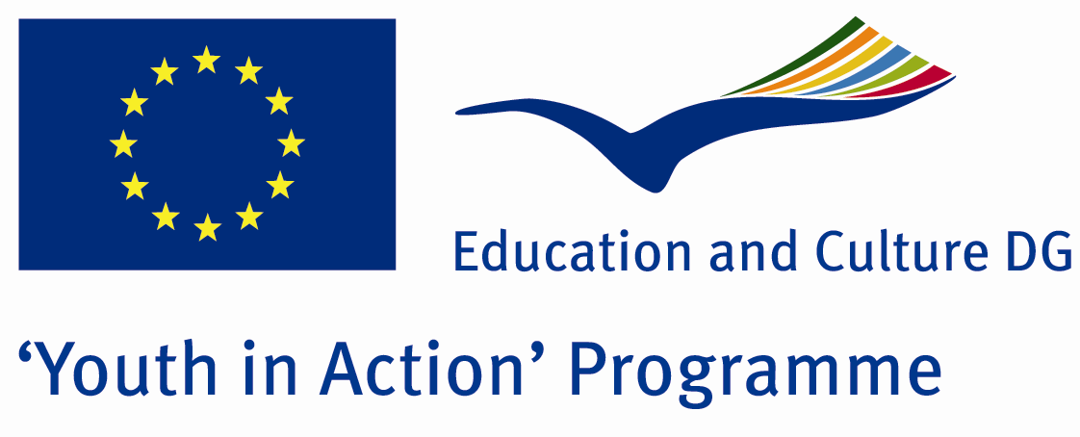

Action 4.3
Project Summary;

Once upon a time, in our Fairy tales, there was a match seller girl. She was hungery, cold and lonely.She died quietly and alone, trembling hands on the streets.Like this, the streets have millions match seller girls and boys.All are alone and scared.Well, while they are in streets, where are we?Let us come together to help these children and share their the endless streets and save them in solitude!

Project Title; My Home in the Streets
Date and Venue ; 02/08 March 2012
Place: İzmit, Turkey.

Target Group ; Municipalities, City Councils and Non-Governmental organizations,
youth groups,culture and art groups,e.t.c

Participants ; 5 people from each country (over 18 -25 ). Totally 8 countries.

Conditions ; Accommodation, board and programme costs will be financed through European Commission Youth in Action Programme . Travel costs will be reimbursed in 70% (APEX Tarrifs). Organizations from all 27 EU member countries plus Liechtenstein , Norway and Iceland are eligible to take part.

Working language: English

Organisator group:Tatanga Group

How to apply: If you are interested, please send your Part III forms to
by e-mail please (in word file). Scan Part3 format is enough for application.(Fulfilled Part III which you can find in the attachment, of course signed and stamped) ..

Contact e-mail: tatangagroup@gmail.com

